Received: 12 January 2025 / Accepted: 10 April 2025 / Published online: 30 April 2025


DOI 10.34689/SH.2025.27.2.004

UDC 616.-006.782-071-053.2(574)

PATHOGENETIC ASSESSMENT OF CLINICAL
AND INSTRUMENTAL PARAMETERS OF THE LUNGS
IN PATIENTS WITH DIABETES MELLITUS

Saule B. Zhautikova¹, https://orcid.org/0009-0000-5712-7369
Nailya M. Urazalina², https://orcid.org/0000-0003-0200-1763
Gulnur A. Bakaramova¹, https://orcid.org/0009-0001-1169-9596
Diana B. Tolubayeva³, https://orcid.org/0000-0003-3119-7814
Gulyash А. Tanysheva², https://orcid.org/0000-0001-9531-5950
Ainash S. Orazalina², http://orcid.org/0000-0003-4594-0138

¹ NCJSC «Karaganda Medical University», Karaganda, the Republic of Kazakhstan;
² NCJSC «Semey Medical University», Semey, the Republic of Kazakhstan;
³ Medical Center Hospital of the Presiden,s affairs Administration of the Republic of Kazakhstan,
Astana, the Republic of Kazakhstan.

Abstract
Background: For the past two decades, many studies have investigated how diabetes mellitus (DM) affects the bronchopulmonary system, but the results have been inconsistent. Diabetes mellitus leads to metabolic disorders and lack of oxygen. And thus causes problems in the lungs and their vessels. One of the common diseases is increased ventilation of the lungs.
Aim of the study is to identify the features and characteristics of the effect of diabetes mellitus and its concomitant pathologies on the morphofunctional state of the respiratory system.
Materials and methods. The sample size was 395 people. A One Touch® glucose meter and a DCA-2000 MT analyzer were used for laboratory and diagnostic assessment of the patients' condition. C-peptide, hormone levels, and insulin resistance indices (Caro and HOMA-IR) were determined using standard laboratory techniques. Instrumental examinations included chest X-rays, computer spirometry, and bronchoscopy.
Results. Lung function disorders were found in the study sample of patients: from bronchial obstruction in type 1 diabetes to restrictive and perfusion disorders in combination with type 2 diabetes with coronary heart disease and obesity.
Conclusion. As a result of the study, it was found that diabetes mellitus is associated with various disorders of respiratory function, including restrictive and obstructive changes, as well as morphological changes in the lung tissue and vascular system. Ultrasound revealed a complex of destructive and inflammatory changes in the lungs.
Keywords: Type 1 and Type 2 Diabetes Mellitus, Abdominal Obesity, Bronchopulmonary Function, Pulmonary Ventilation, Spirometric Assessment, Metabolic Disturbances, Pulmonary Morphology.

For citation: Zhautikova S.B., Urazalina N.M., Bakaramova G.A., Tolubayeva D.B., Tanysheva G.А., Orazalina A.S. Pathogenetic assessment of clinical and instrumental parameters of the lungs in patients with diabetes mellitus // Nauka i Zdravookhranenie [Science & Healthcare]. 2025. Vol.27 (2), pp. 31-38. doi 10.34689/SH.2025.27.2.004

Резюме

ПАТОГЕНЕТИЧЕСКАЯ ОЦЕНКА КЛИНИКО-ИНСТРУМЕНТАЛЬНЫХ ПОКАЗАТЕЛЕЙ ЛЕГКИХ У БОЛЬНЫХ САХАРНЫМ ДИАБЕТОМ

Сауле Б. Жаутикова¹, https://orcid.org/0009-0000-5712-7369
Найля М. Уразалина², https://orcid.org/0000-0003-0200-1763
Гульнур А. Бакарамова¹, https://orcid.org/0009-0001-1169-9596
Диана Б. Толубаева³, https://orcid.org/0000-0003-3119-7814
Гульяш А. Танышева², https://orcid.org/0000-0001-9531-5950
Айнаш С. Оразалина², http://orcid.org/0000-0003-4594-0138

¹ НАО «Медицинский университет Караганды», г. Караганда, Республика Казахстан;
² НАО «Медицинский университет Семей», г. Семей, Республика Казахстан;
³ Больница Медицинского центра Управления делами Президента Республики Казахстан, г. Астана, Республика Казахстан.

Введение: За последние два десятилетия было проведено множество исследований, посвященных изучению влияния сахарного диабета (СД) на бронхолегочную систему, но результаты были противоречивыми. Сахарный диабет приводит к нарушению обмена веществ и недостатку кислорода. И, таким образом, вызывает проблемы в легких и их сосудах. Одним из распространенных заболеваний является повышенная вентиляция легких.
Целью исследования является выявление особенностей и характерных черт влияния сахарного диабета и сопутствующих ему патологий на морфофункциональное состояние дыхательной системы.
Материалы и методы. Объем выборки составил 395 человек. Для лабораторной и диагностической оценки состояния пациентов использовались глюкометр One Touch® и анализатор DCA-2000 MT. С помощью стандартных лабораторных методов определяли уровень С-пептида, гормонов и индексы инсулинорезистентности (Caro и HOMA-IR). Инстру-ментальные исследования включали рентгенографию грудной клетки, компьютерную спирометрию и бронхоскопию.
Результаты. В исследуемой выборке пациентов были обнаружены нарушения функции легких: от бронхиальной обструкции при сахарном диабете 1 типа до рестриктивных и перфузионных нарушений в сочетании с сахарным диабетом 2 типа с ишемической болезнью сердца и ожирением.
Вывод. В результате исследования было установлено, что сахарный диабет связан с различными нарушениями дыхательной функции, включая рестриктивные и обструктивные изменения, а также морфологические изменения в легочной ткани и сосудистой системе. УЗИ выявило комплекс деструктивных и воспалительных изменений в легких.
Ключевые слова: Сахарный диабет 1-го и 2-го типов, абдоминальное ожирение, Бронхолегочная функция, легочная вентиляция, спирометрическая оценка, Метаболические нарушения, морфология легких.

Для цитирования: Жаутикова С.Б., Уразалина Н.М., Бакарамова Г.А., Толубаева Д.Б., Танышева Г.А., Оразалина А.С. Патогенетическая оценка клинико-инструментальных показателей легких у больных сахарным диабетом // Наука и Здравоохранение. 2025. Т.27 (2), С. 31-38. doi: 10.34689/SH.2025.27.2.004

Түйіндеме

ҚАНТ ДИАБЕТІМЕН АУЫРАТЫН НАУҚАСТАРДА
ӨКПЕНІҢ КЛИНИКАЛЫҚ-АСПАПТЫҚ КӨРСЕТКІШТЕРІН
ПАТОГЕНЕТИКАЛЫҚ БАҒАЛАУ
Сауле Б. Жаутикова¹, https://orcid.org/0009-0000-5712-7369
Найля М. Уразалина², https://orcid.org/0000-0003-0200-1763
Гулнур А. Бакарамова¹, https://orcid.org/0009-0001-1169-9596
Диана Б. Толубаева³, https://orcid.org/0000-0003-3119-7814
Гульяш А. Танышева², https://orcid.org/0000-0001-9531-5950
Айнаш С. Оразалина², http://orcid.org/0000-0003-4594-0138

¹ «Қарағанды медицина университеті» КЕАҚ, Қарағанды қ., Қазақстан Республикасы;
² «Семей медицина университеті» КЕАҚ, Семей қ., Қазақстан Республикасы;
³ Қазақстан Республикасы Президенті Іс Басқармасының Медициналық орталығының ауруханасы, Астана қ., Қазақстан Республикасы.

Кіріспе: Соңғы екі онжылдықта көптеген зерттеулер қант диабетінің (ҚД) бронхопульмональды жүйеге қалай әсер ететінін зерттеді, бірақ нәтижелер сәйкес келмеді. Қант диабеті метаболизмнің бұзылуына және оттегінің жетіспеушілігіне әкеледі. Және осылайша өкпеде және олардың тамырларында проблемалар туғызады. Жалпы аурулардың бірі-өкпенің желдетілуінің жоғарылауы.
Зерттеудің мақсаты-қант диабеті мен оның қатар жүретін патологияларының тыныс алу жүйесінің морфофункционалды жағдайына әсерінің ерекшеліктері мен сипаттамаларын анықтау.
Материалдар мен әдістер. Іріктеме көлемі 395 адамды құрады. Пациенттердің жағдайын зертханалық және диагностикалық бағалау үшін One Touch® глюкоза өлшегіші мен DCA-2000 MT анализаторы қолданылды. С-пептидтер, гормондар деңгейі және инсулинге төзімділік көрсеткіштері (Caro және HOMA-IR) стандартты зертханалық әдістермен анықталды. Аспаптық зерттеулерге кеуде Қуысының Рентгенографиясы, компьютерлік спирометрия және бронхоскопия кірді.
Нәтижелер. Пациенттердің зерттеу үлгісінде өкпе функциясының бұзылуы анықталды: 1 типті қант диабетіндегі бронх обструкциясынан жүректің ишемиялық ауруы мен семіздігі бар 2 типті қант диабетімен бірге шектеуші және перфузиялық бұзылуларға дейін.
Қорытынды. Зерттеу нәтижесінде қант диабеті тыныс алу функциясының әртүрлі бұзылыстарымен, соның ішінде шектеуші және обструктивті өзгерістермен, сондай-ақ өкпе тіндері мен тамыр жүйесіндегі морфологиялық өзгерістермен байланысты екені анықталды. Ультрадыбыспен өкпеде деструктивті және қабыну өзгерістерінің кешені анықталды.
Түйінді сөздер: 1 типті және 2 типті Қант диабеті, іштің семіздігі, бронхопульмональды функция, өкпені желдету, спирометриялық бағалау, метаболикалық бұзылулар, өкпе морфологиясы.
Дәйексөз үшін: Жаутикова С.Б., Уразалина Н.М., Бакарамова Г.А., Толубаева Д.Б., Танышева Г.А., Оразалина А.С. Қант диабетімен ауыратын науқастарда өкпенің клиникалық-аспаптық көрсеткіштерін патогенетикалық бағалау // Ғылым және Денсаулық. 2025. Т.27 (2), Б. 31-38. doi: 10.34689/SH.2025.27.2.004

Introduction
Studies on the impact of metabolic control on external respiratory function (ERF) show contradictory results [9], [10]. Some scientific papers say that the relationship between impaired sugar metabolism in the body (carbohydrate metabolism) and lung function (spirometric) is not always found in diabetes mellitus [18]. The duration of diabetes mellitus has a negative effect on the state of the respiratory system. Many patients show both functional and morphological changes in lung tissue. This highlights the mutual effects of the respiratory system and the development of diabetes. [3, 7].
The reason is high sugar levels (hyperglycemia) shown in the Figure 1.
The figure shows the relationship between the effect of the glycemic index level and lung function.

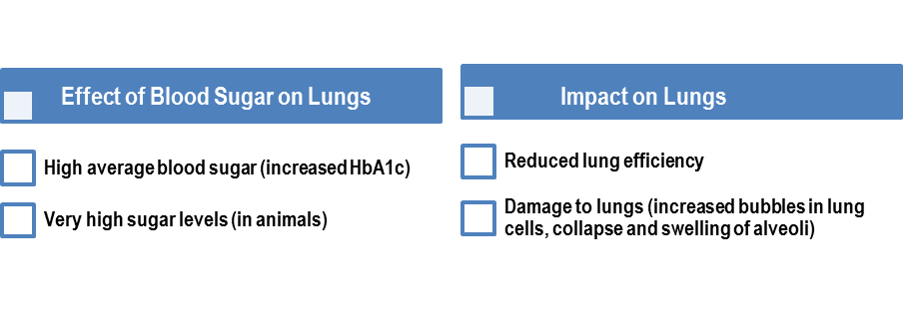
Figure 1. The Relationship Between Blood Sugar Levels and Lung Function.

Aim. To identify the features and characteristics of the effect of diabetes mellitus and its concomitant pathologies on the morphofunctional state of the respiratory system.
Materials and Methods. The studied sample of patients were DM patients, along with 49 individuals without chronic disease serving as controls. Participants were stratified into the following subgroups, according to Table 1.
Table 1.
Сlinical subgroups.
395  patients | 87 patients with type 2 DM (T2DM) and IHD
395  patients | 54 with IHD without T2DM (group X-IHD)
395  patients | 153 with T2DM and obesity
395  patients | 45 with obesity but no diabetes (group Co)
395  patients | 56 with type 1 DM (T1DM), and 24 healthy controls (group C1)

The average age of the T1DM group was 37.5±1.68 years, with disease duration of 11.43±0.32 years. In T2DM patients, the average age was 53.74±2.48 years, with a disease duration of 9.2±0.61 years. The average age in the T2DM + IHD group was 60.1±2.98 years, and IHD duration was 10.7±1.47 years. Effort angina class II was noted in 50% of patients, class III in 23%, class IV in 9%, and myocardial infarction in history in 18% of patients.
The following parameters of abdominal obesity, assessment of glycemia, glycated hemoglobin levels, lipid and protein metabolism, and liver enzymes were diagnosed for the study sample. The following equipment was used: One Touch® glucose meter, DCA-2000 MT analyzer. Methods: the colorimetric method and the Reitman and Frenkel methods.
All participants underwent a questionnaire for respiratory symptoms and a physical examination of the lungs. None of the patients had chronic lung diseases or respiratory complaints. Smoking was noted in some patients: 9.2% smoked regularly, 5.8% — sporadically.
The following instrumental, functional and radiation research methods were used (figure 2).

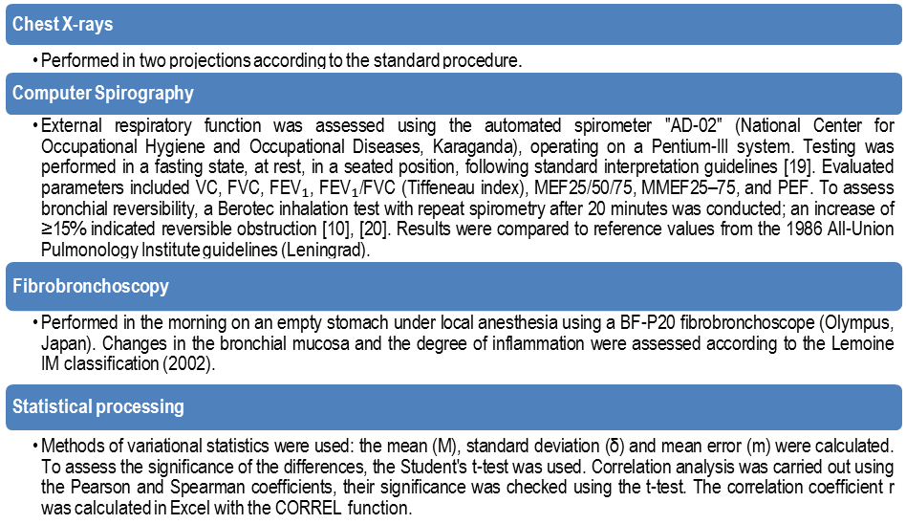

Figure 2. Instrumental, functional and radiation research methods.

Results
No clinically evident signs of lung pathology were revealed during the examination. Slight percussion-auscultatory changes were noted in 20.23% of patients: shortening of percussion sound — in 4.05% (DM1), 6.98% (DM2) and 9.25% (DM2+CHD); in 29.48%, prolonged expiration was observed, mainly over the lower lobe of the right lung. Vesicular breathing with prolonged expiration was observed in 13.87% of cases, weakened — in 3.47%. Fluorography did not reveal any pathologies, while standard radiography in two projections revealed a number of changes detected in Figure 3.
These signs are regarded as a non-specific reaction of the bronchopulmonary system to chronic exposure
In patients DM2, the changes included: lung roots - 30.68%, increased transparency - 28.14%, increased pattern - 33.3%, interstitial changes - 22.22%, bulging of the pulmonary artery arch - 6.82%. In 10 patients, pleural adhesions were found, indicating previous pneumonia.
Аll values are shown in the Figure 4.
In the study group of patients with T2DM, pathological changes in the lungs were detected (Fig. 5) in 49%.

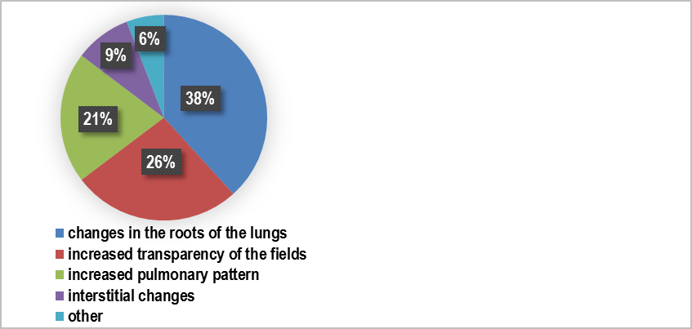
Figure 3. Identified radiological signs.

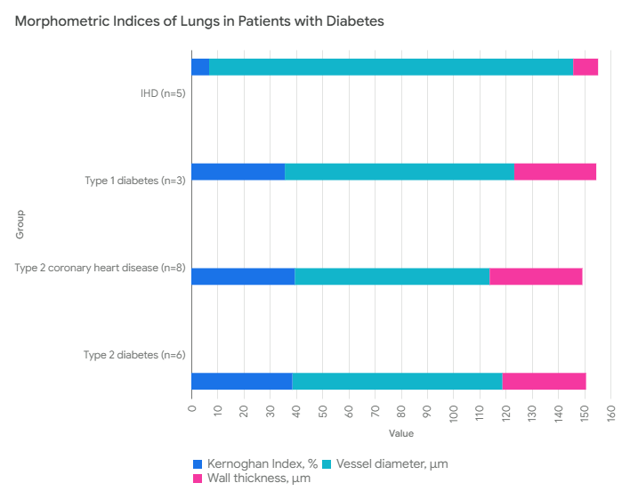
Figure 4. Morphometric Indices of Lungs in Patients with Diabetes.

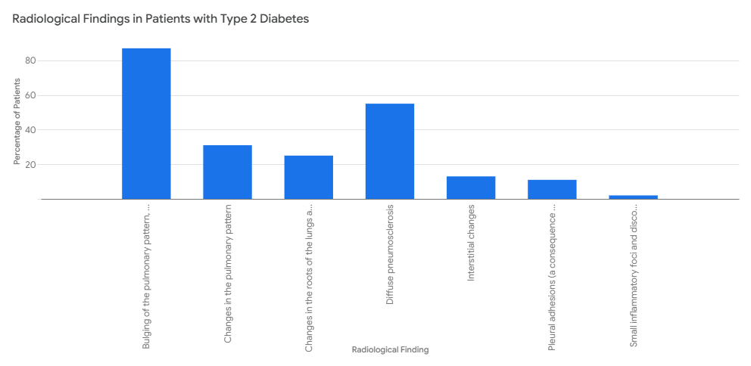

Figure 5. Lung Findings in Type 2 Diabetes.

According to Figure 6, diabetes mellitus affects the bronchopulmonary system. However, patients with concomitant diseases, such as cardiovascular pathology and thyroid diseases, were the most susceptible.
External Respiratory Function (ERF) Study in patients with diabetes mellitus (DM) revealed pulmonary ventilation disorders associated with the severity of DM. For the identified sample, determining lung ventilation disorders, radiology, endoscopy, and PVD were performed. The results are shown in the figure 6.
FVD disorders were found in 23% of 175 patients, with a decrease in speed indicators and patency of the central airways. Illustrated below is a clustered bar graph displaying the quantitative values of various indices for each group, enabling a detailed examination of the data distribution and patterns (Figure 7).

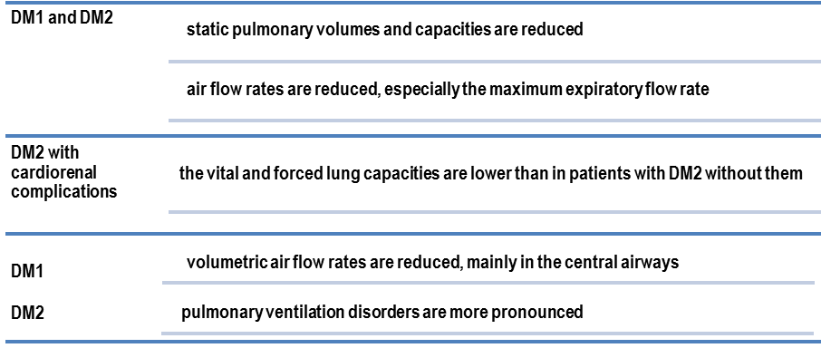

Figure 6. Violations of the function of external respiration
in patients with diabetes mellitus have been revealed

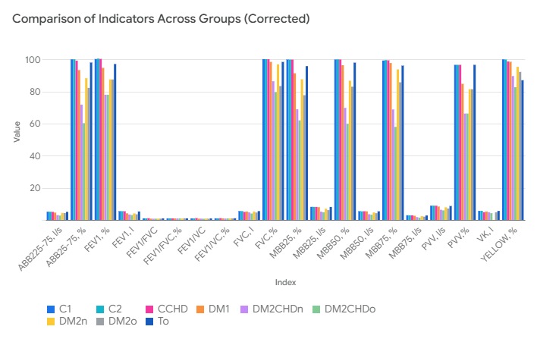
Figure 7. Comparative Analysis of Indices by Group.

The results of the Berotec test demonstrated that the bronchospastic component in the formation of respiratory disorders in severe type 2 diabetes mellitus plays a limited role, since a positive response was recorded only in 20% of patients. In 68% of patients with severe vascular complications, multiple respiratory function disorders were detected: FEV₁, Tiffen index, and air flow velocity decreased, involving both small and large bronchi.
Fiberoptic bronchoscopic characteristics of the state of the bronchial mucosa.
Bronchoscopy was performed for patients with type 1 and type 2 diabetes. Specific diffuse lesions of the bronchopulmonary system are shown in the figure 8.

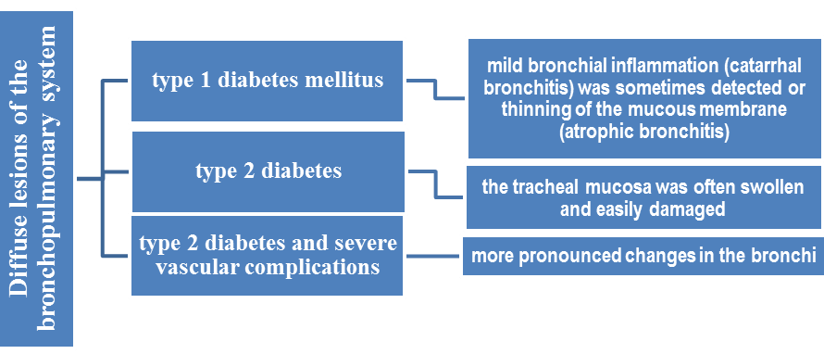
Figure 8. Revealed diffuse changes by bronchoscopy.

X-rays also showed that almost half of these patients have impaired patency of the small bronchi. This was confirmed by a trial with Berotec, a medicine that dilates the bronchi. Patients with diabetes mellitus, especially in combination with cardiovascular diseases, are more likely to show radiological signs of lung damage and impaired respiratory function. A positive bronchodilator test was recorded in 45% of patients, and signs of bronchial inflammation were found in 21%.
Pathological disorders of the lungs in patients with diabetes mellitus. Histological examination showed that some patients with type 1 diabetes (23%) develop alveolitis, followed by the formation of alveolar fibrosis and microcystic tissue transformation. Structural changes of varying severity were observed at the level of blood vessels of the small circle of blood circulation, including thickening of the walls, hyperplasia of the muscular membrane and sclerosis, which indicates a progressive violation of pulmonary hemodynamics and an increase in vascular resistance (Figure 9).

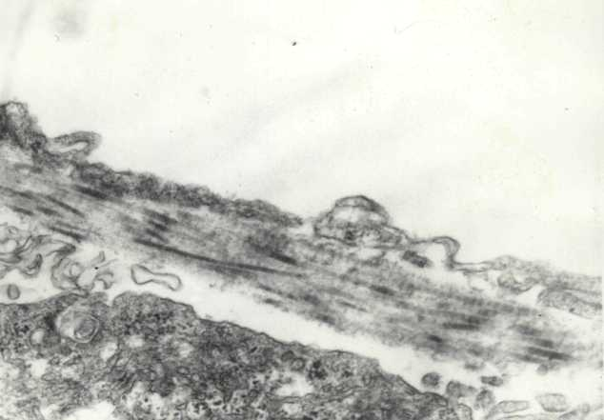  a) (CD1) sclerosis of the interalveolar capillary wall.  KV |  | 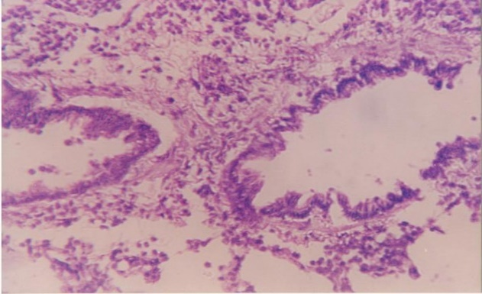  b) (DM2) – diffuse fibrosis of the bronchial wall.

Figure 9. Pathomorphology of the lungs in DM patients.

In patients with type 2 diabetes mellitus (in 5-24.9% of cases), vascular lesions were generalized, manifested by significant narrowing of the vascular lumen, thickening of the vascular wall, destructive changes in the elastic membrane and pronounced hyperelastosis of venous structures. In some cases, endophlebitis in the interlobular veins was observed, indicating a chronic inflammatory process.
The most pronounced morphological changes in lung tissue were detected in patients with a combination of type 2 diabetes and cardiovascular pathologies. These patients had marked alveolar fibrous rearrangement, which led to impaired gas diffusion and the development of persistent hypoxemia. In conditions of pulmonary hypertension, the vascular walls showed pronounced swelling, plasma infiltration, structural deformation, and loss of barrier function due to endothelial damage. These processes increased the risk of hemorrhages and contributed to the destruction of the vascular bed.
Morphometric study of the lungs of patients with diabetes mellitus.
Morphometric analysis of the lungs of deceased patients (9 men and 8 women, mean age 67.4±2.4 years) with type 1 and type 2 diabetes mellitus showed changes associated with atherosclerotic lesions (Figure 10).
It has been found that in people with diabetes, the small vessels in the lungs become narrower and their walls thicker. Because of this, the blood passes through them worse, and there is increased pressure in the lungs. This interferes with normal blood flow and makes it difficult for the lungs to function. The most pronounced changes are observed when type 2 diabetes mellitus is combined with coronary heart disease. Morphological signs of vascular remodeling in this category of patients indicate the formation of latent pulmonary arterial hypertension.

Figure 10. Morphometric indices of the lungs in patients with diabetes (autopsy material).

Discussion
According to comprehensive examination data, changes in the bronchopulmonary system were detected in 43.93% of cases in patients with DM. X-ray changes are more often detected than changes during physical examination, especially when DM2 is combined with coronary artery disease. In 68% of patients with DM2 in PS, disorders of the function of external respiration (LVEF) of restrictive, obstructive and mixed types were detected. The Berotec test showed a decrease in the significance of bronchial reactivity in DM, which indicates the predominance of sclerotic processes. Violations of FVD, in particular, a decrease in FEV1 and VVC, are considered as an independent risk factor for mortality in diabetes [1, 2, 5, 6, 8, 11-16, 18]. In the study [8], spirography indicators were more dependent on the state of metabolic control of carbohydrate metabolism in patients with T2DM. Obesity, diseases of the cardiovascular system, and the duration of the disease contributed to impaired bronchial patency. In addition, a 10% decrease in FEV1 was associated with a 12% increase in mortality among the surveyed.
The results of studies that have revealed a link between spirography and mortality make it possible to consider deterioration of respiratory function as an independent risk factor for mortality, and the determination of FEV1 and VVC as indicators of health status [11], including in diabetes [12], [13], [14]. It was found that VVC in diabetes mellitus decreases to a greater extent than FEV1.
The pathological process in DM involves the bronchopulmonary system, causing functional and morphological changes, including changes in the vessels of the small circle of blood circulation. In conditions of pulmonary hypertension, a compensatory venoarterial reaction and vascular restructuring occur.
The importance of closure-type vessels as regulators of blood supply in the pulmonary circulation in conditions of pulmonary hypertension plays an important pathogenetic role. The presence of a longitudinal muscle layer in the vessels of the closure type makes it possible to completely stop blood flow in one or another part of the microcirculatory bed and helps to change its direction.
Conclusions
38.4% of people with type 1 diabetes had breathing problems. This was manifested by the fact that the air passed worse through the respiratory tract, especially in large bronchi, and increased air resistance. 23.3% of people with type 2 diabetes had shallow breathing due to poor alveolar function. In some patients (21.3%), bronchial inflammation, deterioration of respiratory parameters and difficulty in gas exchange in the lungs were found.
The majority of patients with type 2 diabetes (62%) had both obstructive (difficulty getting air out) and restrictive (decreased lung volume) breathing disorders. They also had bronchial inflammation, a severe decrease in lung volume, and impaired blood flow in the lungs.
A deeper (microscopic) examination of the lungs of diabetic patients revealed alveolar damage, inflammation, scarring of tissue and destruction of the vascular membrane. This led to hemorrhages, edema, and vascular thickening in most cases.

Conflict of Interest. The authors declare that they have no conflict of interest.
Contribution of authors. All authors were equally involved in the writing of this article.
Funding: No funding was provided.

References:
- Abdikadirova Kh., Amreyeva K., Zhautikova S., Kostyleva O., Abikenova F., Chergizova B. et al. Morphological Changes in the Hepatic Tissue at the Impact of Industrial Copper-bearing Dust in the Experiment. Open Access Macedonian Journal of Medical Sciences. 2020; 8(E): 653-656. https://doi.org/10.3889/oamjms.2020.3473
- Abdikadirova K.R., Amreeva K.E., Kalishev M.G., Zhautikova S.B Evaluation of the effectiveness of alimentary correction of pathological changes in hepatic tissue under the influence of industrial copper-containing dust in the experiment. Meditsina Truda I Promyshlennaya Ekologiyathis link is disabled, 2019; 59(7):438–443. https://doi.org/10.31089/1026-9428-2019-59-7-438-443
- Androsova T.A. Functional and morphological manifestations of pulmonary lesions in diabetes mellitus: Abstract. Candidate of Medical Sciences.14.00.16. St. Petersburg. 1992. 17. https://medical-diss.com/docreader/396842/a#?page=3
- Bloomgarden Z.T. Developments in diabetes and insulin resistence. Diabetes Care. 2006. 29:161-167. https://pubmed.ncbi.nlm.nih.gov/16373919/
- Jangildinova S, Ivassenko S, Kelmyalene A, Yessilbayeva B, Dyussenbekova B. Determination of the product of DNA oxidation in the blood of women living in the sub-aral area. Open Access Maced J Med Sci. 2019. 7(10):1672-4. https://doi. org/10.3889/oamjms.2019.333 PMid:31210821.
- Klein B., Moss S., Klein R., Cruickshanks K. Is peak expiratory flow rate a predictor of complications in diabetes? The Wisconsin Epidemiologic Study of Diabetic Retinopathy J. Diabetes Complications. 2001. 15:301-306. https://doi.org/10.2337/DIACARE.27.2007.S84
- Kostovski M., Simeonovski V., Mironska K., Tasic V., Gucev Z. Metabolic Profiles in Obese Children and Adolescents with Insulin Resistanceю. Open Access Maced J Med Sci.2018;15; 6(3):511-518 https://oamjms.eu/index.php/mjms/article/view/oamjms.2018.097/1977
- Kumar A.R., Malik S., Tiwari R., Zhautivova S.B., Rakhimovna A.H., Raj T., et al. Pathophysiology of cardiovascular diseases and the role of vitamins, and herbal extracts in the reduction of cardiovascular risks. Cardiovasc Hematol Agents Med Chem. 2021.19(2):175-86. https://doi.org/10.2174/1871525718666201 217102638.
- Kalyagin A.N., Asner T.V. The concept of insufficiency of function external respiration. Spirography. Diagnosis of obstructive and restrictive respiratory failure. Irkutsk. 2005. p 28. https://mir.ismu.baikal.ru/src/downloads/efa0f3ed_kalyagin_asner_spiro.pdf
- Miller M.R., Hankinson J., Brusasco V., Burgos F., Casaburi R., Coates A., Crapo R., et al. Standardisation of spirometry. Eur. Respir. J. 2005/ 26(2):319-338. https://erj.ersjournals.com/content/26/2/319
- Mori H., Okubo M., Okamura M. Abnormalities of pulmonary function in patients with non-insulin-dependent diabetes mellitus.Intern. Med.1992/ 31:189-193. https://www.jstage.jst.go.jp/article/internalmedicine1992/31/2/31_2_189/_pdf/-char/en
- Okassova A.K., Britko V., Okassov D.B., Tatina Y.S., Tolegenova A.I., Kuvatbaeva K.N., et al. Study of lipid peroxidation-antioxidant defense systems in rats under radiation exposure. Open Access Maced J Med Sci. 2022. 10(A):236-9. https://doi.org/10.3889/ oamjms.2022.8352.
- Oivin I.A. Statistical processing of experimental research results. Pathological physiology and experimental therapy. 1960; 4: 76-85.
- Perelman Y.M., Prikhodko A.G. Spirographic diagnostics of violations of the ventilation function of the lungs: A manual for doctors: 2nd edition, supplement. Blagoveshchensk.2013. p 44. https://docplayer.com/26037783-Spirograficheskaya-diagnostika-narusheniy-ventilyacionnoy-funkcii-legkih.html
- Sokolov E.I., Zaichikova O.S. Diabetic heart: Metabolic reasons for the development of cardiomyopathy. Problems of Endocrinology. 1996. 42(6):20-26. (In Russ.). https://www.probl-endojournals.ru/probl/article/view/12056
- Stavem K., Aaser E., Sandvik L. Lung function, smoking and mortality in a 26-year follow-up of healthy middle-aged males. Eur. Respir. J. 2005. 25:618-625. https://erj.ersjournals.com/content/25/4/618
- Santos E., Fonseca C.M., Manco J.C., Gallo Junior L. Cholinergic bronchomotor tone and airway caliber in insulin-dependent diabetes mellitus.1992. 101:1038-1043. https://www.researchgate.net/profile/Milton-Foss/publication/21601146
- Tussupbekova M., Bakenova R., Stabayeva L., Imanbayeva G., Nygyzbayeva R., Mussabekova S., Tayzhanova D. Clinic - Morphologic and Morphometric Criteria for Differential Diagnosis of Sarcoidosis and Pulmonary Tuberculosis. Open Access Maced J Med Sci. 2019:13. 7(9):1480-1485. doi: 10.3889/oamjms. 2019.315. PMID: 31198459; PMCID: PMC6542409.
- Weiss S. Pulmonary function as a phenotype physiologic marker of cardiovascular morbidity and mortality. Chest. 2001. 99:265-266. https://journal.chestnet.org/action/showPdf?pii=S0012-3692%2816%2948817-3
- Zhautikova S, Abdikadirova K, Zhienbayeva K, Suleimenova B, Talaspekova Y, Karipova A, Baryshnikova I, Zhalmakhanov M, Piven L, Medvedeva I, Zhuravlev S, Omarbekova N. Pathogenetic Mechanisms of Relationship of Metabolic and Morphofunctional Disorders of Thyroid and Adrenal Glands in Diabetes Mellitus and Obesity. Open Access Maced J Med Sci. 2022.10(B):232-9. https://oamjms.eu/index.php/mjms/article/view/8151

Information about the authors:
*Zhautikova Saule - Professor of the Department of Physiology of NJSC «Karaganda Medical University», Gogol str. 40, Karaganda 100000, Kazakhstan. https://orcid.org/0009-0000-5712-7369; е-mail: zhautikova@qmu.kz; Cell phone +7 701 299 34 07
Urazalina Nailya - Candidate of Medical Sciences, Associate Professor of the Department of physiological disciplines named after honored scientist of the republic of Kazakhstan, professor T.A. Nazarova, NJSC "Semey Medical University", Semey, Kazakhstan; phone: 8 777 907 55 89, е-mail: hakim_15@mail.ru, https://orcid.org/0000-0003-0200-1763,
Bakaramova Gulnur - Assistant Professor of the Department of Physiology of NJSC «Karaganda Medical University», Gogol str. 40, Karaganda 100000, Kazakhstan. https://orcid.org/0009-0001-1169-9596; е-mail: Bakaramova@qmu.kz; Cell phone +7 778 675 33 64
Tolubayeva Diana - Doctor PhD “Medical Center Hospital of the President affairs Administration of the Republic of Kazakhstan” Astana, https://orcid.org/0000-0003-3119-7814; е-mail: dianajianna@gmail.com; Cell phone +7 701 299 34 06.
Tanysheva Gulyash – Candidate of Medical Sciences, Head of the Department of Obstetrics and Gynecology, NCJSC «Semey Medical University», phone 8(777)153-53-57, email gulyash1965@mail.ru, https://orcid.org/0000-0001-9531-5950, Semey, Kazakhstan;
Orazalina Ainash – Candidate of Biological Sciences, Associate Professor, Head of the Department of Molecular Biology and Medical Genetics named after Academician of the National Academy of Sciences of the Republic of Kazakhstan T.K. Raisov, NJSC «Semey Medical University», phone; +7-777-235-47-72; e-mail: ainash.orazalina@smu.edu.kz; https://orcid.org/0000- 0003-4594-0138; Semey, Kazakhstan.

*Corresponding author:
Zhautikova Saule - Professor of the Department of Physiology of NJSC «Karaganda Medical University», https://orcid.org/0009-0000-5712-7369; Karaganda, Kazakhstan.
Address: Gogol str. 40, Karaganda 100000, Kazakhstan.
е-mail: Zhautikova@qmu.kz;
Cell phone +7 701 299 34 07

